GreyBox Testing

Greybox testing is a software testing method to test the software application with partial knowledge of the internal working structure. It is a combination of black box and white box testing because it involves access to internal coding to design test cases as white box testing and testing practices are done at functionality level as black box testing.
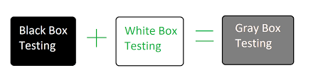
- In White Box testing internal structure (code) is known
- In Black Box testing internal structure (code) is unknown
- In Grey Box Testing internal structure (code) is partially known

Example of Gray Box Testing: While testing websites feature like links or orphan links, if tester encounters any problem with these links, then he can make the changes straightaway in HTML code and can check in real time.
Gray Box Testing is performed for the following reason:
- It provides combined benefits of both black box testing and white box testing both
- It combines the input of developers as well as testers and improves overall product quality
- It reduces the overhead of long process of testing functional and non-functional types
- It gives enough free time for a developer to fix defects
- Testing is done from the user point of view rather than a designer point of view

Techniques used for Grey box Testing are-
- Matrix Testing: This testing technique involves defining all the variables that exist in their programs.
- Regression Testing: To check whether the change in the previous version has regressed other aspects of the program in the new version. It will be done by testing strategies like retest all, retest risky use cases, retest within a firewall.
- Orthogonal Array Testing or OAT: It provides maximum code coverage with minimum test cases.
- Pattern Testing: This testing is performed on the historical data of the previous system defects. Unlike black box testing, gray box testing digs within the code and determines why the failure happened

